Ms. Campbell

ASSIGNMENT #2  **DUE-Friday 4/17/2020**

Art History Re-Enactments

Studio in Art (period 12) & Advanced Studio in Art (Period 3, 6/7 and 8/9)

**HOW WILL YOU TURN IN YOUR WORK**

You will send me an e-mail with the picture of the recreated artwork and your summary. Make sure you tell me who is sending it!! I do not now your personal emails!! At the top of the page you need this heading:

First name, Last Name

Art period

Date

Assignment Name

**Part 1**

You will chose a work of art to re-create at home. You can choose *any* work of art that you think that you can re-create at home.

**When you are looking through works of art to recreate here are some things to think about:**

**Clothing and fabric:**

What are the people in the art work wearing? Can you create something *Similar.*  It does not and never be exactly like the real artwork.

**People**

You can use yourself as a model. You can use members of your family.

**Background**

The background is important. Be careful what is in your background!!!!! Make sure the you do not have items that should not be there…(For example-my daughter’s head is blocking my address.)

****TAKE A PICTURE ON YOUR PHONE***

**Part 2**

Write up a summary about what you did and why.

Items to include:

-What is the name and the artist of the artwork you recreated?

-What can you tell me about that artwork?

-Explain how you re-created the artwork.

-Tell me about your process recreating this in your own words.

_________________________________________________________________

EMAIL ME YOUR ASSIGNMENT: [Ncampbell@nfschools.net](mailto:Ncampbell@nfschools.net)

*\*And a side note~* Have fun with this! Get creative! Laugh! (I was laughing so hard because my daughters didn’t want to go in the front yard! lol) Include your family or your pet! Make it work the best you can! I can’t wait to see your results!

**EXAMPLES:**

My daughters re-creating “American Gothic” by Grant Wood

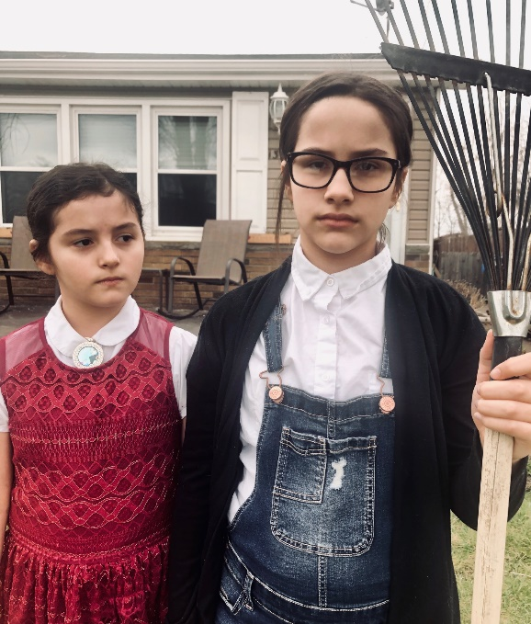 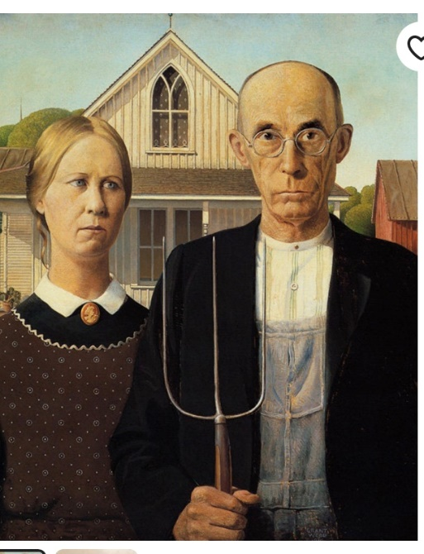

**Some I found online:**

“Arnolfini Portrait” by Jan van Eyck

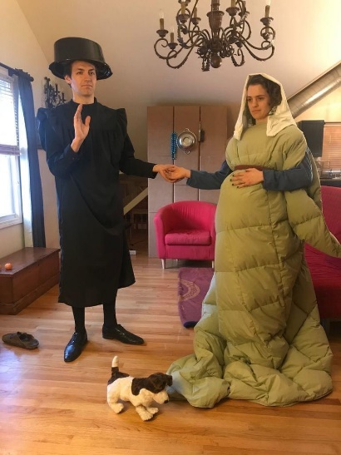 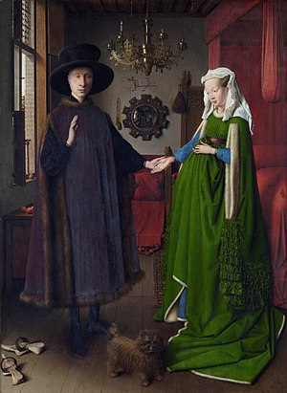

“Girl with a Paerl Earring” by Johannes Vermeer

